Constance Burton
AP Physics
Motion Lab

PROCEDURE
Part I
- Develop a position vs. time story that describes a body in motion.
  - Start walking 3 meters to the bathroom. This takes 5 seconds. Accelerate another 3 meters to arrive in time to pee. This takes 2.5 seconds. Peeing takes 20 seconds. Run back to the classroom for 5 meters at 2.5 seconds, but slow to a walk the last 1 meter at 5 seconds.
- Graph:

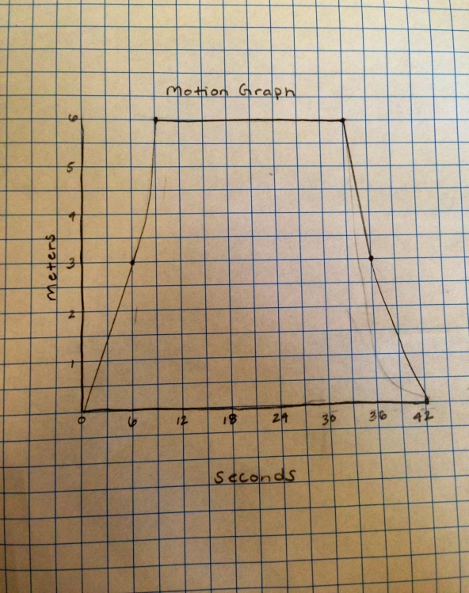

- To use the motion detector, act out the story at a scale of 1/3.

Part II
- Graph:

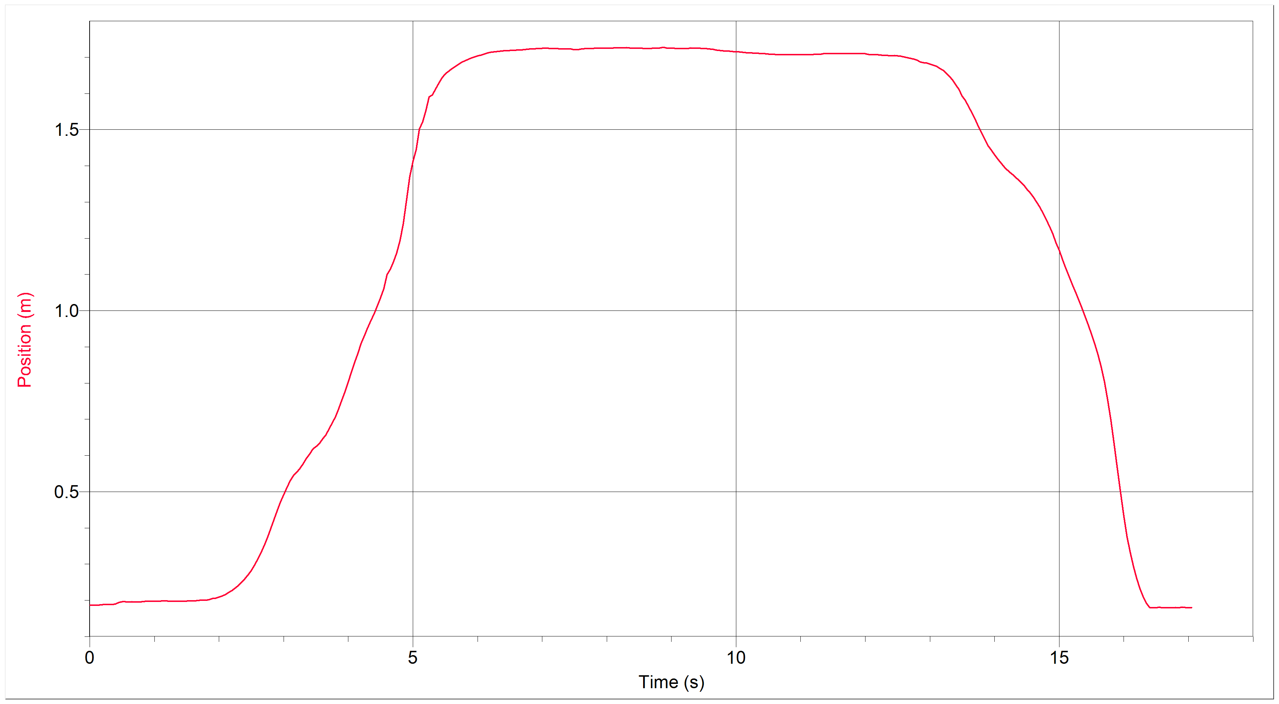

- Data Analysis: The graphs were roughly the same; however, the right slope on the Logger Pro graph slopes outwards, while the hand-drawn graph slopes inward and then outward.

- Conclusion: The motion lab introduced us students how to properly use a motion detector and Logger Pro to develop a displacement vs. time graph. We also had to develop our own graph using our knowledge of velocity. My lab partner and I came very close to matching our graph sketch with the LoggerPro graph.

