Constance Burton
Electrostatics Lab

Purpose: To discover several ways to charge insulators.
Materials: Simulation “Balloons and Static Electricity”
Procedure:
- Start the simulation Balloons and Static Electricity. Charge the balloon by rubbing it against the sweater. Click and drag the yellow balloon over to the sweater and rub it against the sweater.
- Confirm that the balloon is charged by dragging it away from the sweater and then releasing the balloon. Record your observations in the Data section of your lab report.
- This method of charging objects by transferring charges between them is called charging by friction or rubbing. In the Data Analysis section of your report, draw a picture of the sweater and balloon. Indicate the charge distribution on both and the direction of the force between them on your drawing.
- Now, charge the wall by bringing the charged yellow balloon near it. Record your observations in the Data section of your lab report.
- This method of charging is known as charging by polarization. It requires polar molecules such as those in the paint on the wall that are free to move around. In the Data Analysis section, draw the balloon and the wall. Indicate the charge distribution for the wall and the balloon as well as the direction of force on your drawing.
Data:
- After charging the balloon against the sweater, the balloon became negatively charged and when released, the balloon was attracted to the sweater.
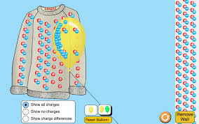
Blue=Negative Charge

- The balloon is negatively charged, and when brought toward the wall, the negative charges in the wall moved away from the balloon.
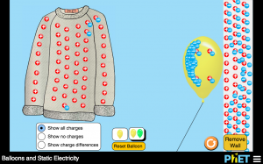
Blue=Negative Charge

Conclusion:
1) What type of charge was transferred from the sweater to the balloon? Negative.
2) What type of charge did the sweater have at the beginning of the experiment? Neutral.
3) What type of charge did the sweater have at the end of the experiment? Positive.
4) What type of charge did the edge of the wall have before the experiment? Neutral.
5) What type of charge did the edge of the wall have when the balloon was brought near it? Positive.
6) Compare/contrast charging by friction and charging by polarization.
- Friction is a transfer of electrons from one object (sweater) to another (balloon) by rubbing.
- Polarization is electrical attraction between a charged particle (positive or negative) and a neutral particle; attraction occurs when the charged particle repels the same charge in the neutral particle making the neutral particle the opposite charge. (EX: When the negatively charged balloon pushed away the negative charges in the wall, it became attracted to the remaining positive charges.

