Constance Burton
Measurements Lab

Step 1: Measurement of the Wooden Block
-Procedure:
- Utilize a ruler to measure the three side of a wooden block and then, using the collected data, find the volume using the formula $l×w×h$
-Data:
Height | Length | Width | Volume
15 cm | 1.6 cm | 8.2 cm | $${196.8 cm}^{3}$$

-Calculations:
$$15cm×1.6cm×8.2cm={196.8cm}^{3}$$

Step 2: Volume of a Cylinder
-Procedure:
- Use a Vernier Caliper to calculate the diameter of the cylinder and use a ruler to determine the height. Use the formula $V=πr^{2}h$ to find the volume of the cylinder.
-Data:
Diameter | Height | Volume
7.1mm | 100mm

-Calculations:
$$V=π{3.55mm}^{2}×100mm$$
$$V={3959mm}^{3}$$

Step 3: Thickness of a Piece of Paper
-Procedure:
- Use a caliper to measure the thickness of 100 sheets of paper and then divide that number by 100 to find the thickness of 1 sheet of paper.
-Data:
Thickness of 100 Sheets of Paper | 5.4mm
Thickness of 1 Sheet of Paper | .054mm

-Calculations:
$$5.4mm÷100=.054mm$$
Step 4: Measure the Volume of the Classroom
-Procedure:
- Collect the measurements of each wall and then find the volume of each protrusion and then subtract the data from the total volume.
-Data: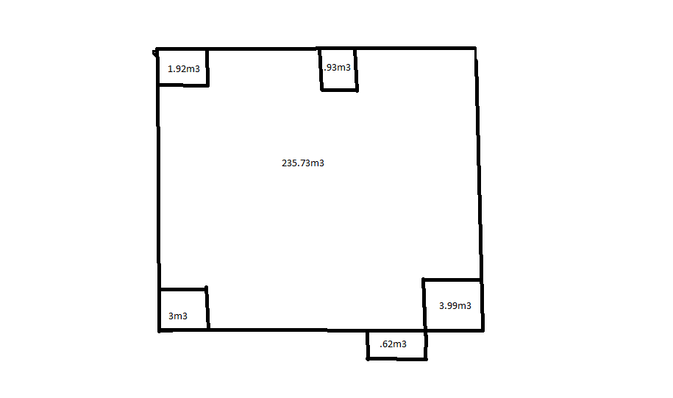

-Calculations:
$${235.73m}^{3}-{1.92m}^{3}-{.93m}^{3}-{3.99m}^{3}-{3m}^{3}+{.62m}^{3}={226.51m}^{3}$$
$$Volume of the Classroom= {226.51m}^{3}$$

Conclusion:
The purpose of the Measurement Lab was to allow the student to become familiar with different types of measuring tools. The vernier caliper was used for more precise, smaller measurements, while the ruler or meter stick was used to measure larger, and more flat areas. Unfortunately while measuring the classroom, calculations can be incorrect due to protrusions in the wall and the length of the room.

