Constance Burton
Mrs. Geddes

Scenario 1
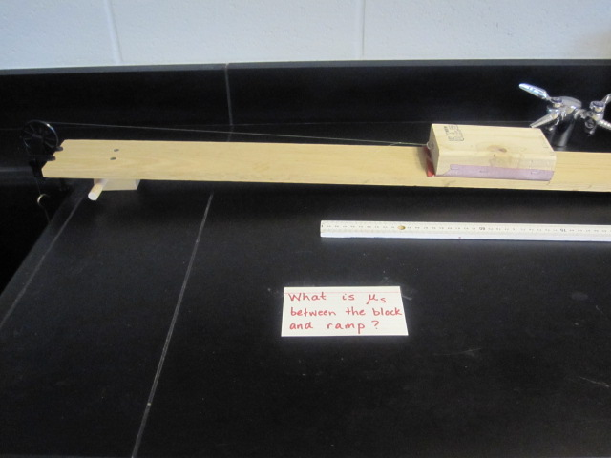
- What is the Coefficient of Static Friction?
- Calculation:
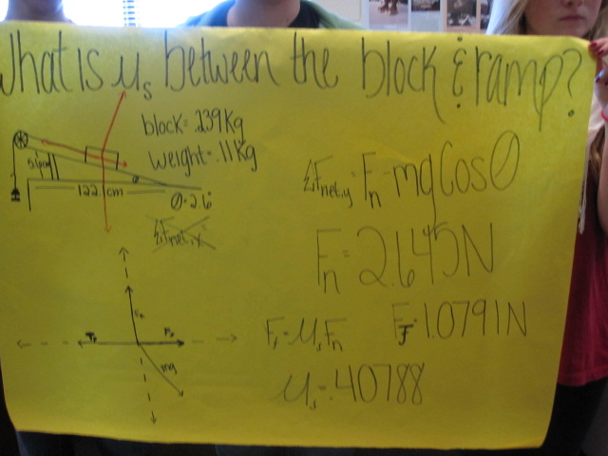

Scenario 2
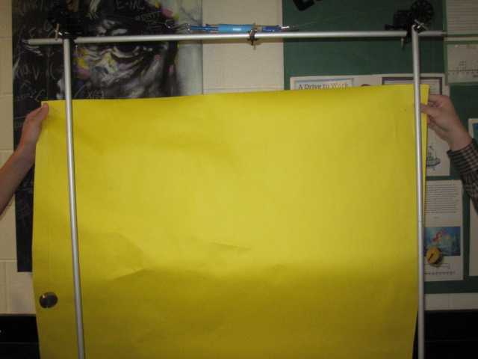
- What should the spring scale read?
- Calculation:
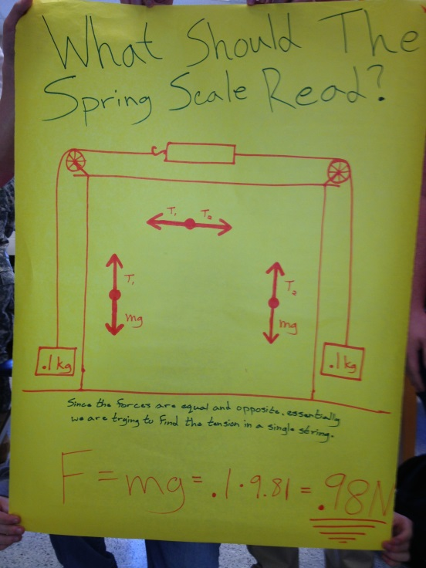

Scenario 3
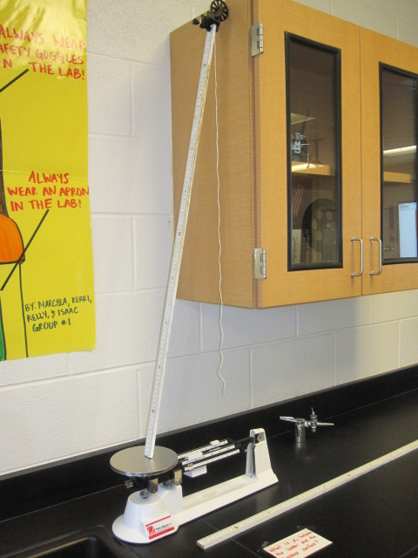
- Find and expression for the force of friction using only the coefficient of static friction in the expression.
- Calculation:
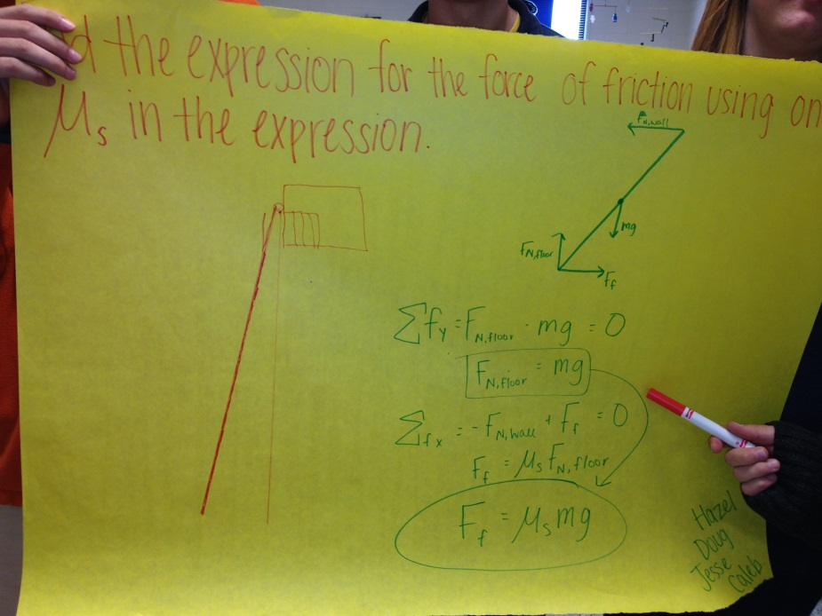
Scenario 4
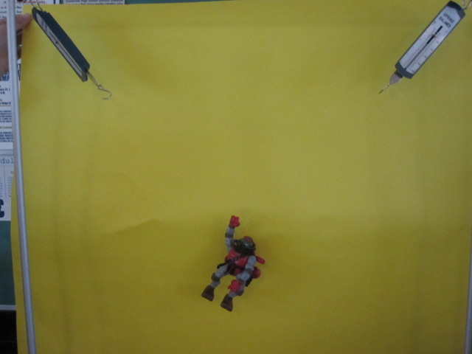
- What is the mass of the turtle?
- Calculation:

